**Article title (14 pts, bold, spaced one and capitalise the first word only)**

**Author's Name1, Author's Name2 + Orchid for each authors**  **(11 pts)**

**1Department, University, City, Country; 2Department, University, City, Country (9 pts)**

**Provide full correspondence details here including e-mail for the *corresponding author (9 pts)**

**Abstract:** Please write the abstract in English and in Bahasa Indonesia (for native speaker) max 250 words. Abstract contains about: the purpose and scope of the study; the method used; a summary of results; conclusion. These instructions give you guidelines for preparing papers for Education and Human Development Journal. Use this document as a template if you are using Microsoft Word 7.0 or later. Otherwise, use this document as an instruction set. Define all symbols used in the abstract. Do not cite references in the abstract. Do not delete the blank line above the abstract immediately; it sets the footnote at the bottom of this column. Abstract is written in 10 pts font size.

**Keywords**: Put 5 your keywords here; keywords separated by semicolon

**Introduction (Indentation starts from the second paragraph, spaced before 6 pts and capitalise the first word only)**

The introduction must contain (sequentially) general background, previous literature studies (*state of the art*) as the basis for the statement of scientific renewal of the article, a statement of scientific renewal, and a research problem or hypothesis. At the end of the introduction, the purpose of the article should be written.

**Literature review (if any) (Indentation starts from the second paragraph, spaced before 6 pts and capitalise the first word only)**

A literature review is a piece of academic writing demonstrating knowledge and understanding of the academic literature on a specific topic placed in context.

**Methods (Indentation starts from the second paragraph, spaced before 6 pts and capitalise the first word only)**

Please write the methodologies in great detail. Position yourself as a researcher not a methodology book writer.

The description of the table on the left (*left*) and in the usual font size of 9 pts. Caption 9 also (Please refer to APA 7th edition)

|  |  |  |  |
| --- | --- | --- | --- |
| Pseudonym | Field/ specialisation | Gender | grade |
| Example | Example | Example | 7 |
| Example | Example | Example | 7 |
| Example | Example | Example | 7 |
| Example | Example | Example | 7 |

**Results/Finding (For qualitative study it is recommended to use ‘Finding’. Indentation starts from the second paragraph, spaced before 6 pts and capitalise the first word only)**

The results section contains research findings obtained from research data and is related to hypotheses.

Please check all images in your article, both on screen and printed versions. When checking the printed version of the image, make sure that: (1) the colour has sufficient contrast, (2) the image is clear enough, (3) all labels on the image can be read.

**Discussion (Indentation starts from the second paragraph, spaced before 6 pt and capitalise the first word only**

Page numbers, headers and footers are not used. All hypertext links and bookmark marks will be deleted. If the paper needs to refer to the e-mail address or URL in the article, the full address or URL must be typed in a normal font.

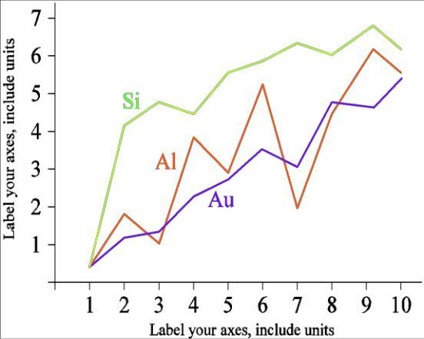

Figure 1. Example of a Line graph using contrasting Colors Times New Roman 9 and Examples of images with good resolution and appropriate size

**Conclusions (Indentation starts from the second paragraph, spaced before 6 pt and capitalise the first word only)**

Part conclusions answer to hypotheses, research objectives, and research findings and suggestions related to further ideas from research.

**Recommendation (Indentation starts from the second paragraph, spaced before 6 pts and capitalise the first word only)**

**References** (10 points, no space between lines, before 6 pts)

**All references** referred to in the text of the article must be registered section in the **References List**. Writing **List** of **library/References** (*bibliography*) and **citation** (*citation*) with ***style is* APA 7th *edition*** are recommended using the Mendeley application.

**Example**:

Moorhouse, B. L. 2022. Teaching abroad during initial teacher education: the effects as perceived by recently qualified teachers on their preparedness for teaching. *Asia Pacific Journal of Education,* 42(4), 760–771. <https://doi.org/10.1080/02188791.2020.1755222>

Car, W., & Kemmis, S. (2004). *Becoming critical: education, knowledge and action research*. Taylor & Francis