Original Research

Title: Modification of Research Objectives

Author¹, Author², Author¹, and Author³
Bhinneka Tunggal Ika Journal of Counseling
January-June 2024: 1–13
© The Author(s) 2024
DOI:
https://propanoramic.com/index.php/btijc/index

Abstract
A maximum of 200 words abstract in English with book antiqua font 11 point, 1 spacing, justify, italic. The abstract should be clear, and descriptive, and should provide a brief overview of the problem studied. Abstract topics include the discipline area, the purpose of the article, reasons for the selection or the importance of research topics, research methods, hypothesis, the results of research, research contribution in the discipline area, and a summary of the results. The abstract should end with a comment about the importance of the results or conclusions brief.

Plain Language Summary
Teachers are an essential component that must be considered in an educational institution. Through this research, we are curious about what components can influence school-based management, especially from the teacher aspect. We surveyed 476 teachers at the elementary school level in Indonesia, and the data was then analyzed. This research found that the length of time a teacher works does not affect school-based management, nor does the teacher’s perception of online learning and mental health. This means that even though the school is filled with new or old teachers, its management is acceptable. On the other hand, teachers who have received teacher certification allowances have an impact on their professionalism. Therefore, providing certification allowances to professional teachers is crucial to improve the school-based management system. Unexpected findings regarding teacher status, whether private or civil servant, apparently have no effect on school-based management.

¹Universitas Nahdlatul Ulama Surabaya, Indonesia
²Universitas Indonesia, Surabaya, Indonesia
³Universitas Bina Nusantara, Jakarta Barat, DKI Jakarta, Indonesia
⁴Universitas Negeri Surabaya, East Java, Indonesia

Corresponding Author:
Fifi Khoirul Fitriyah, Department of Early Childhood Education, Universitas Nahdlatul Ulama Surabaya, Jl. Raya Jemursari No.57, Jemur Wonosari, Kec. Wonocolo, Surabaya, Jawa Timur 60243, Indonesia.
Email: fifi@unusa.ac.id


Creative Commons CC BY: This article is distributed under the terms of the Creative Commons Attribution 4.0 License (https://creativecommons.org/licenses/by/4.0/) which permits any use, reproduction and distribution of
the work without further permission provided the original work is attributed as specified on the SAGE and Open Access pages (https://us.sagepub.com/en-us/nam/open-access-at-sage).

Keywords
Keyword1, Keyword2, Keyword3, Keyword4, and Keyword5

Introduction
Paragraph 1: Tell us about the importance of this topic to one of [Science, society, or technology]
Paragraph 2: Tell us what previous research has done, either chronologically or grouping
Paragraph 3: Tell us what are the obstacles/ gaps/ weaknesses of previous research
Paragraph 4: The purpose and significance of this research

Method

Research Design
2.1 Materials
If the research topic is correlation or other quantitative research, then write down all the research respondents and their characteristics. If the topic is technology, you can write down the location of the research or where the secondary data used was obtained.

2.2 Data collection procedures
Write in full how the analyzed data was obtained. Or write down how the experiment was carried out or write down how the sampling was done. Don't forget to write references.

2.3 Data analysis procedures
Write in full how the data that has been collected is analyzed to answer the objectives. Narrate sequentially in paragraph form. Don't forget to write references.

Participants
A total of 474 elementary school teachers under Indonesian republican teacher union, Magetan district branch, East Java, Indonesia, participated in this study. Table 1 shows the demographic characteristics of respondents.

Procedure
Participants in this study are voluntary without any com- pensation. The data collection method used an online questionnaire distributed to primary school teachers in Magetan Regency, East Java, Indonesia. Online ques- tionnaires were distributed via social media WhatsApp. Researchers asked participants to fill out a questionnaire to measure their perceptions of school management sys- tem, online learning, literacy learning implementation, and positive mental health through the google form.

Measurement
In this study, we used four questionnaires; the School Management Scale (Smith et al., 2015), Teacher’s Online Learning Perception, Literacy Learning Implementation (Faizah et al., 2016), and Positive Mental Health (Lukat et al., 2016). Three of the original questionnaires were in English, so an adaptation process was needed. The three instruments are the school management scale, teacher’s online learning perception, and positive mental health.
The adaptation process follows WHO standards; for- ward translation, expert panel back-translation, pre- testing and cognitive interviewing, and final version (World Health Organization, 2021). For the forward translation section and the back-translation expert panel, we have passed the ethical clearance test, including all questionnaire which also has passed such a test. In the pre-testing and cognitive interviewing section, we used

Results

3.1 Topic 1

Explain clearly the results and discussions that have been obtained in the following format: (i) what is this?, (ii) what is the data pattern like [try to be detailed]?, (iii) explain why the data pattern is like that [try to be detailed], and ( iv) compare with previous research.

Example of Table and Figure

Demographic characteristics and descriptive statistics
A total of 1004 Indonesian undergraduate-level students attending university in East Java, Indonesia, participated in the research study. Table 3 shows the demographics, the statistics of age variables in different subcultures, gender, field of sciences, and years of formal education.
Table 3. Socio-demographic details of respondents
 | n (%) | Age
 | n (%) | Range | mean ± SD
Respondents by subcultures
Arek | 528 (52.59%) | 15-30 | 20.91 ± 2.51
Madura | 140 (13.94%) | 17-30 | 20.62 ± 2.03
Matraman | 221 (22.02%) | 18-30 | 20.57 ± 2.13
Pandalungan | 115 (11.45%) | 18-27 | 20.73 ± 1.50
Respondents by gender
Male | 251 (25%) | 15-30 | 21.77 ± 2.27
Female | 753 (75%) | 15-30 | 20.77 ± 2.27
Respondents by the field of science
Health Sciences | 197 (19.62%) | 15-30 | 20.58 ± 2.18
Education | 415 (41.33%) | 18-30 | 20.99 ± 2.45
Social Sciences | 190 (18.92%) | 18-30 | 20.65 ± 2.22
Mathematic and Natural Science | 35 (3.49%) | 18-27 | 20.83 ± 1.79
Engineering | 167 (16.63%) | 17-30 | 20.52 ± 2.02
Respondents by years of completing formal education
13 years | 284 (28.29%) | 15-30 | 20.45 ± 1.89
14 years | 296 (29.48%) | 18-30 | 20.83 ± 2.25
15 years | 278 (27.69%) | 18-30 | 20.71 ± 2.15
16 years | 146 (14.54%) | 18-30 | 21.40 ± 2.99

Arek Data | 0,904
Madura Data | 0,9
Matraman Data | 0,964
Pandalungan Data | 0.659

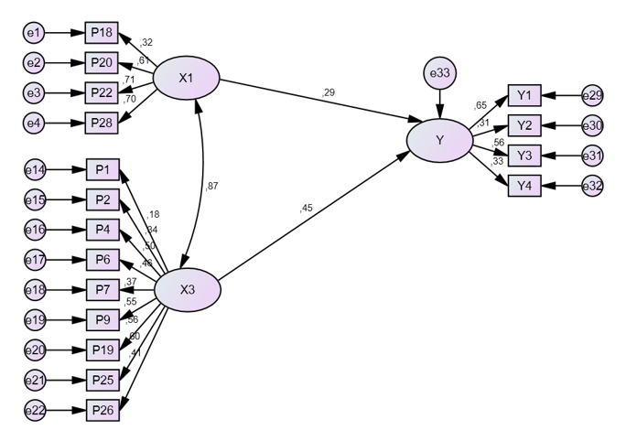

Fig. 1. Standardized total effects of meaning of purpose (X1) and interconnectedness (X3) to empathy (Y).

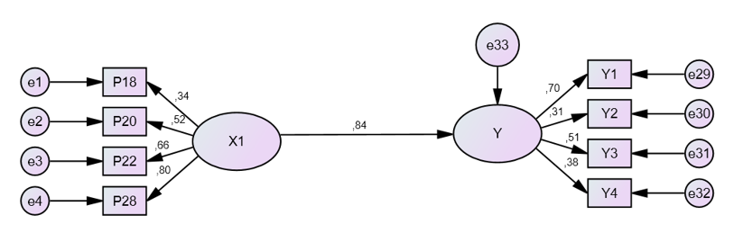

Conclusion
Rewrite the objective so that it reminds the reader what has been done (1 sentence). Convey results according to specific objectives (3-4 sentences). The impact and significance are conveyed (1 sentence). Recommendations for further research (1 sentence)

Acknowledgments
We are grateful to all respondents involved in this research project. We are also grateful to the XXXX, which supports funding of this study with contract number: XXXX.

Declaration of Conflicting Interests
The authors of this study certify that they have NO affiliations with or involvement in any organization or entity with any financial interest (such as honoraria; educational grants; participation in speakers’ bureaus; membership, employment, consultancies, stock ownership, or other equity interest; and expert testimony or patent-licensing arrangements), or non-financial interest (such as personal or professional relationships, affiliations, knowledge or beliefs) in the subject matter or materials discussed in this manuscript.

Funding
The author(s) disclosed receipt of the following financial sup- port for the research, authorship, and/or publication of this article: We are also grateful to Institute of Research and Community Service, Universitas Nahdlatul Ulama Surabaya, which supports funding of this study with contract number: 040/UNUSA/Adm-LPPM/III/2021.

ORCID iD
Fifi Khoirul Fitriyah https://orcid.org/0000-0002-4087-0022

Data Availability Statement
The dataset generated during and/or analysed during the current study are available from the corresponding author on reasonable request.

References
Use APA style. We recommend using reference management such as EndNote, Mendeley, etc.

